Fast Food Marketing Campaign A\B Test
Introduction
A fast-food chain plans to add a new item to its menu. However, they are still undecided between three possible marketing campaigns for promoting the new product. In order to determine which promotion has the greatest effect on sales, the new item is introduced at locations in several randomly selected markets. A different promotion is used at each location, and the weekly sales of the new item are recorded for the first four weeks.
Goal
Evaluate A/B testing results and decide which marketing strategy works the best.
Columns
- MarketID: unique identifier for market
- MarketSize: size of market area by sales
- LocationID: unique identifier for store location
- AgeOfStore: age of store in years
- Promotion: one of three promotions that were tested
- week: one of four weeks when the promotions were run
- SalesInThousands: sales amount for a specific LocationID, Promotion, and week
The consist of 7 column and 546 rows
Task
- The dataset is aggregated by LocationID, PromotionID and week. You should aggregate by LocationID and PromotionID before conducting the statistical tests.
- Since there are three marketing campaigns and you have to select the best-performing one, you will have to conduct several tests, comparing campaigns against one another.. This kind of testing is known as pairwise comparisons and it suffers from the multiple testing problem - if we run a lot of tests, there’s an increased chance of getting a type I error (false positive). It is therefore suggested to use the confidence level of 99% instead of the traditional 95% in your graded task.
Solution
Firstly, I ran SQL query to perform the first task which can be discovered at Appendix 1. Where the dataset was aggregated by LocationID, PromotionID and week.
Result of the aggregated sales for each promotion are as follows:
Row | promotion | avg_sales | stddev_sales | no_of_locations
1 | 1 | 232.4 | 64.11 | 43
2 | 2 | 189.32 | 57.99 | 47
3 | 3 | 221.46 | 65.54 | 47

STATISTICAL TESTS
Using Pairwise Comparison of Promotions
To determine if there are any statistically significant differences between the average sales of the three promotions.
The tests perform are:
- Promotion 1 vs. Promotion 2
- Promotion 1 vs. Promotion 3
- Promotion 2 vs. Promotion 3
Null Hypothesis and Alternative Hypothesis
For each pairwise comparison, I set up the following hypotheses:
- Null Hypothesis (H₀): There is no difference in average sales between the two promotions.
- Alternative Hypothesis (H₁): There is a significant difference in average sales between the two promotions.
Bonferroni Correction
Since I’m running multiple tests, there is need to adjust the significance threshold using the Bonferroni correction. With 3 pairwise comparisons, the adjusted significance level was:
α_{adjusted} = $\frac{0.01}{3}$ =0.0033
I had to compare the p-values for each pairwise test with this adjusted threshold.
T-TEST
To t-test for each of the pairwise comparisons to determine if the difference in average sales is statistically significant at the 99% confidence level.
Promotion 1 vs Promotion 2
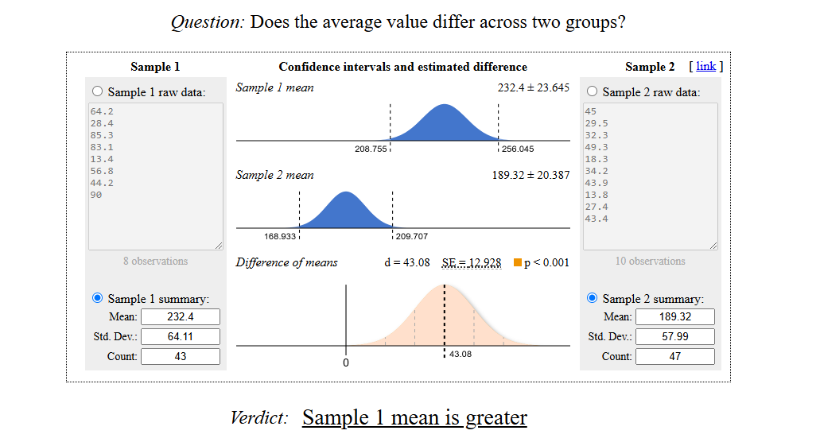

- t-statistic: 3.33
- p-value: 0.00128
Since the p-value (0.00128) is less than the significance level of 0.0033, the difference in average sales is statistically significant, indicating that Promotion 1 performs better than
Promotion 1 vs Promotion 3:
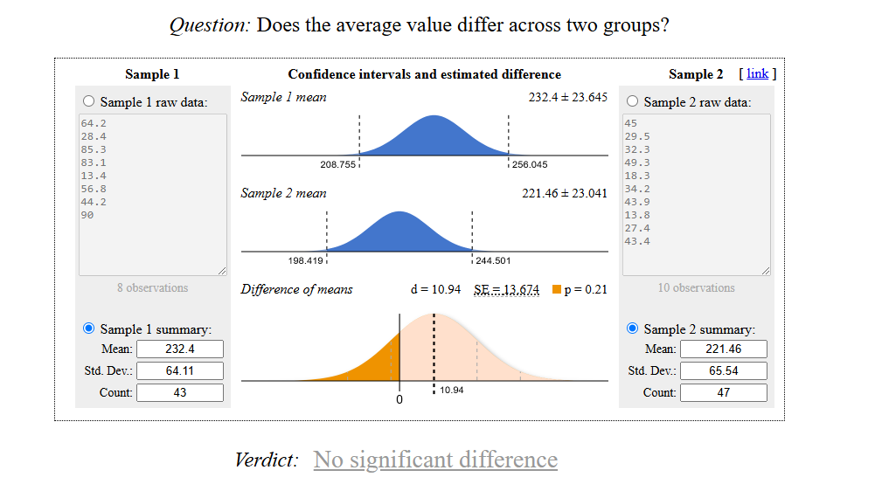
- t-statistic: 0.80
- p-value: 0.426
The p-value (0.426) is greater than 0.0033, so there is no statistically significant difference in average sales between Promotion 1 and Promotion 3.

Promotion 2 vs Promotion 3
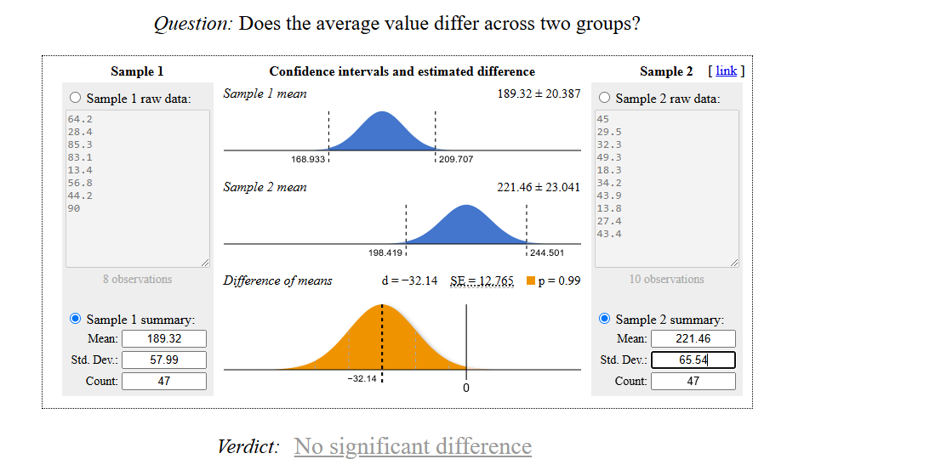
- t-statistic: -2.52
- p-value: 0.0136
The p-value (0.0136) is greater than 0.0033, so there is no statistically significant difference in average sales between Promotion 2 and Promotion 3.

Row | promotion | avg_sales | stddev_sales | no_of_locations
1 | 1 | 232.4 | 64.11 | 43
2 | 2 | 189.32 | 57.99 | 47
3 | 3 | 221.46 | 65.54 | 47

Conclusion
- Promotion 1 outperforms Promotion 2 significantly in terms of average sales.
- There is no statistically significant difference between Promotion 1 and Promotion 3, nor between Promotion 2 and Promotion 3.

Recommendation
Promotion 1 appears to be the most effective marketing campaign based on the pairwise comparison. You might want to consider continuing or expanding this promotion to maximize sales.

Appendix 1
WITH
mean_table AS(
SELECT
location_id,
promotion,
SUM(sales_in_thousands) AS sum_sales,
COUNT(week) AS weeks_count
FROM
`tc-da-1.turing_data_analytics.wa_marketing_campaign`
GROUP BY
location_id,
promotion
ORDER BY
promotion,
location_id )
SELECT
promotion,
ROUND(AVG(sum_sales),2) AS avg_sales,
ROUND(STDDEV(sum_sales),2) AS stddev_sales,
COUNT(location_id) AS no_of_locations
FROM
mean_table
GROUP BY
promotion;

